1. Start the Oracle Client Installer.

Note: Using “Deinstall Products” to remove the failed installation if necessary.

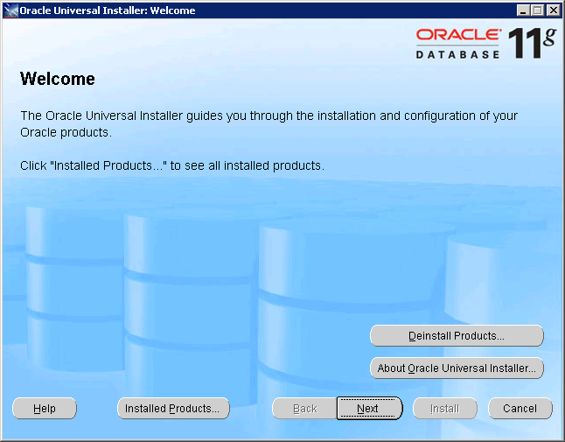

1. Using the default path

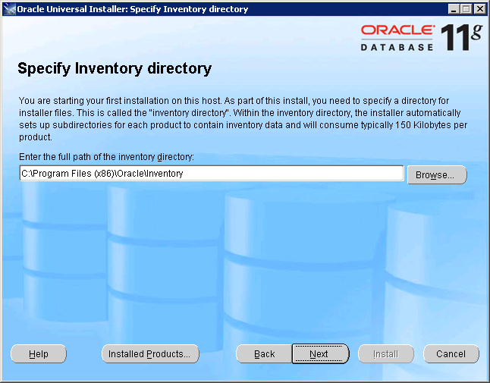

1. Select Oracle Data Access Components for Oracle Client 11.2.0.2.1

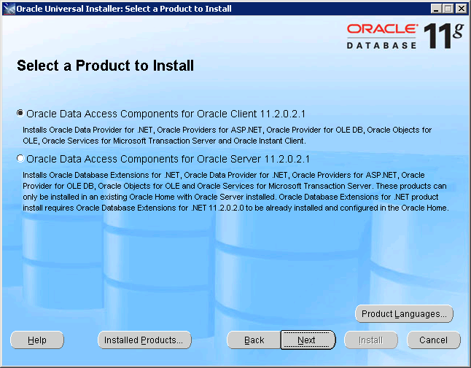

1. Using the Default settings.

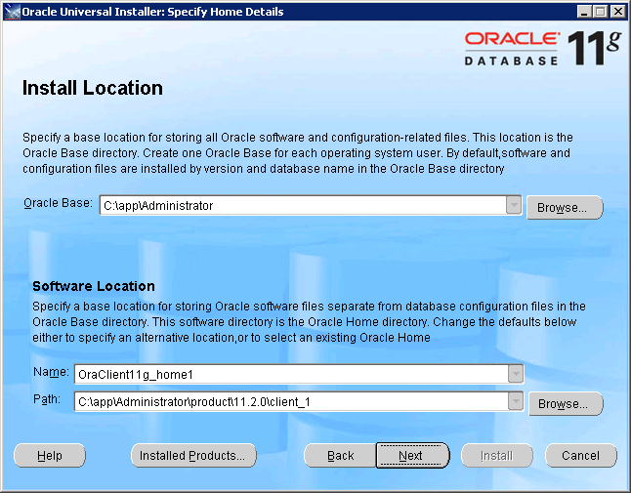

1. Deselect the unnecessary components

“Oracle Providers for ASP.NET 11.2.0.2.0”

“Oracle Services For Michrosoft Transaction Server 11.2..0.2.0”

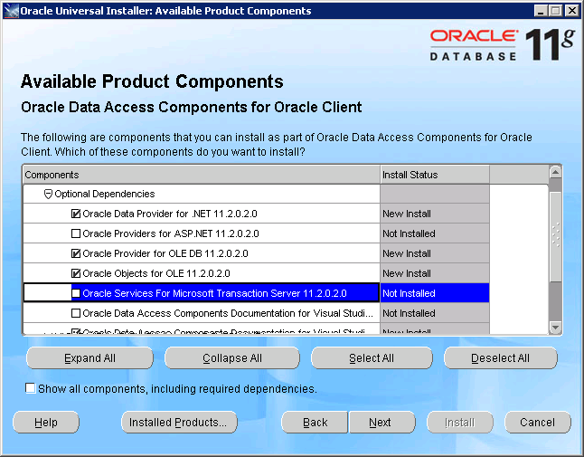

1. Click Next to install

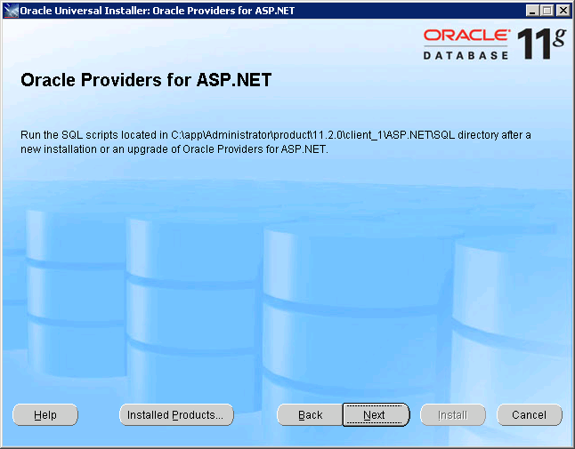

1. Check installer information and Click Install

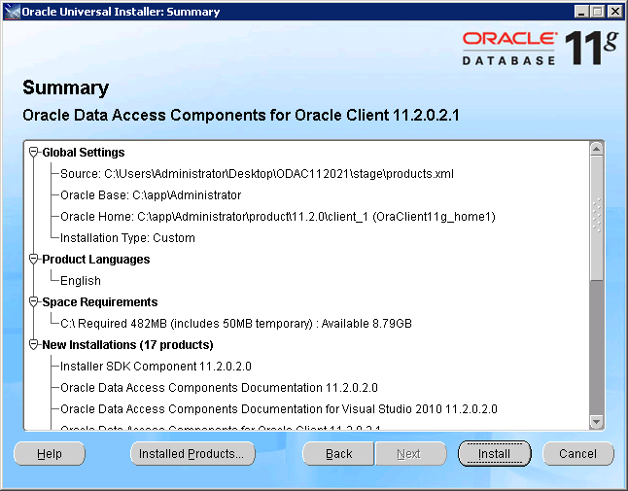

1. Run installation

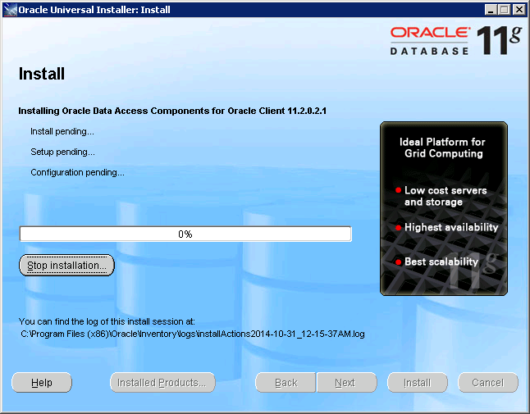

1. Installation Successful

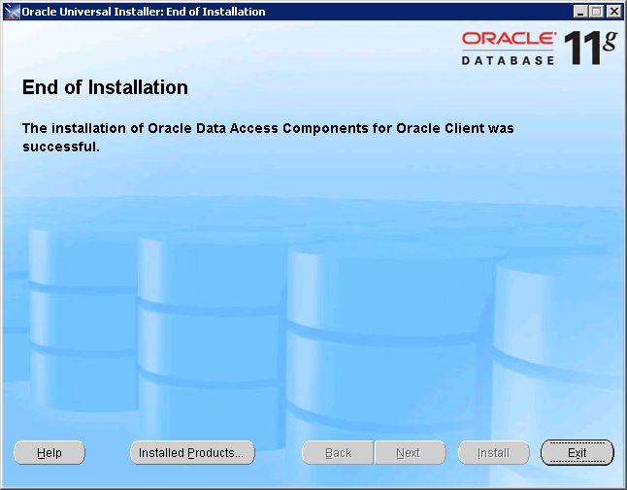

1. Restart Computer.
2. Lunch FD Servers and you will see connection successful.

